July 28, 2021

Team Lead Meeting for Case Studies

**People: Isabel, Noor, Elle, and Qiuyu**

* Need to confirm with Ikhlaq whether he wants a separate “Case Studies” tab

July 8, 2021

Team Lead Meeting for Case Studies

**People: Isabel, Noor, Felipe, Vincent, Keyana, Zhiyue, Steven**

* Shared everything from our meeting with Elle and Qiuyu with the entire team
* All lululemon projects will be completed in September, including the research one
* The LAM research project is just getting started because they’re having NDA issues, so their timeline is even later
* We’ll have a check-in with everyone once we receive the wire frame from Elle and Qiuyu

July 7, 2021

Meeting for Innovation-X Website/Case Studies

**People: Isabel, Noor, Elle, Qiuyu**

* Case study overview
* Can maybe create a separate tab for the redesigned innovation-x website
* Similar style as Data-X website Projects tab: <https://datax.berkeley.edu>
* Example:
  + SCET Case Study - Bridging Academia with Industry Experience
* Format:
  + 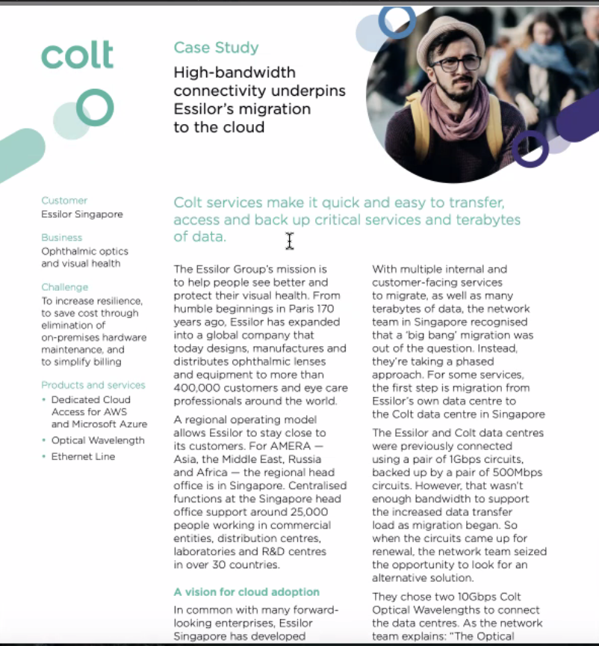
* The case studies will most likely be incorporated in the About section or the IE affiliations section, which includes SCET and Innovation-X information.
* Include the actual framework of the projects
  + How innovation engineering works
    - Insightful story
    - Solution
    - 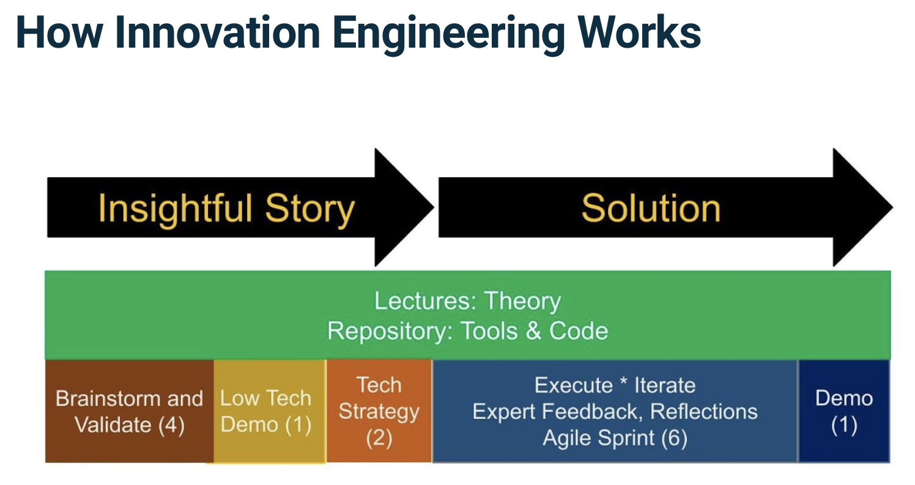
* Can possibly embed the recordings of the final presentations in the case study
* [www.inkrypt.io](http://www.inkrypt.io)
* Can possibly write medium articles and embed them into the case studies if there are enough
  + Can show system architecture and show it to other teams for feedback
* The About tab is going to have a subtab of framework templates and the process of how Innovation Engineering works (strategy, low tech demo, etc.) for users to understand each one better and be able to download their templates.
* There will also be two additional sections about the framework regarding more humanistic values.
* The concept database will have a ton of subsections with a menu on the side.
* Innovation Index and Automated Teaming section with tools.
* Showcase team dynamic, majors, how they worked together, what made their teamwork efficient
  + Include the concepts from the Concept Database in the About section
    - <https://www.innovation-engineering.net/about/concept-database>
  + Elle said she would reach out to us about which ones are extremely important
* Cast Study Format
  + Creating the story of the problem space and how the students are going to solve the problem
  + More in depth description of the solution
  + Explain the system architecture and how the team is going to have a more tangible outcome
  + Sprints
  + Final Deliverables
  + Quotes on the sides (maybe left)
  + All the way at the bottom
    - Who made up the team
    - What worked/didn’t work
* Estimated time for wire frame
  + Within the next 2 weeks